Part 1:

sudo awk -F: '($2 == "" ) { print $1 }' /etc/shadow

sudo find / -type f -perm -o+w
sudo find / -type d -perm -o+w

sudo -i

echo "Secure Server" > /root/secure.txt

gpg --symmetric --cipher-algo AES256 --passphrase Passw0rd /root/secure.txt

rm /root/secure.txt

echo "default-cache-ttl 0" >> ~/.gnupg/gpg-agent.conf

sudo nano /etc/ssh/sshd_config

Edited: PermitRootLogin no

sudo systemctl restart sshd

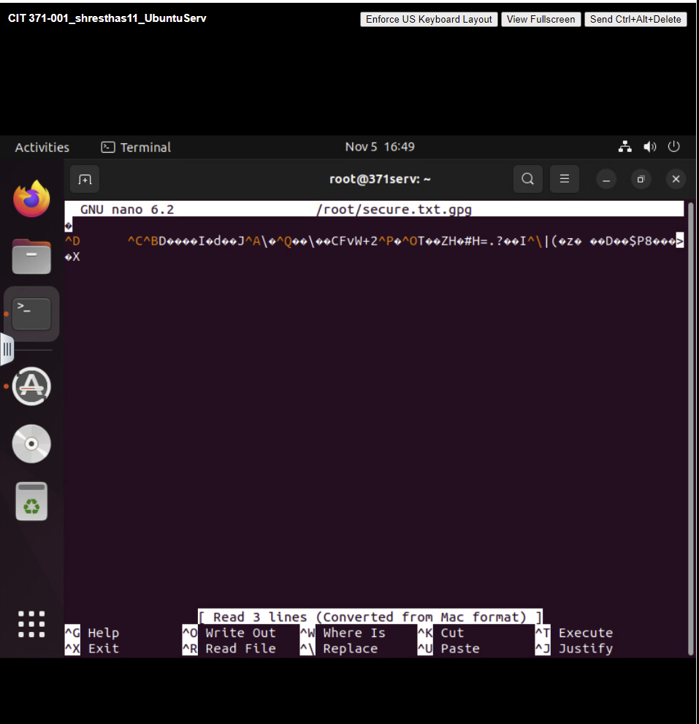

Part 2:

sudo ufw enable
sudo systemctl enable ufw

sudo ufw status verbose

sudo ufw logging on

sudo ufw deny 23

sudo ufw insert 1 allow 8080

sudo ufw delete allow ssh

sudo ufw allow from 192.168.1.210 to any port 22

